**Selecting the S3 bucket you want to delete**

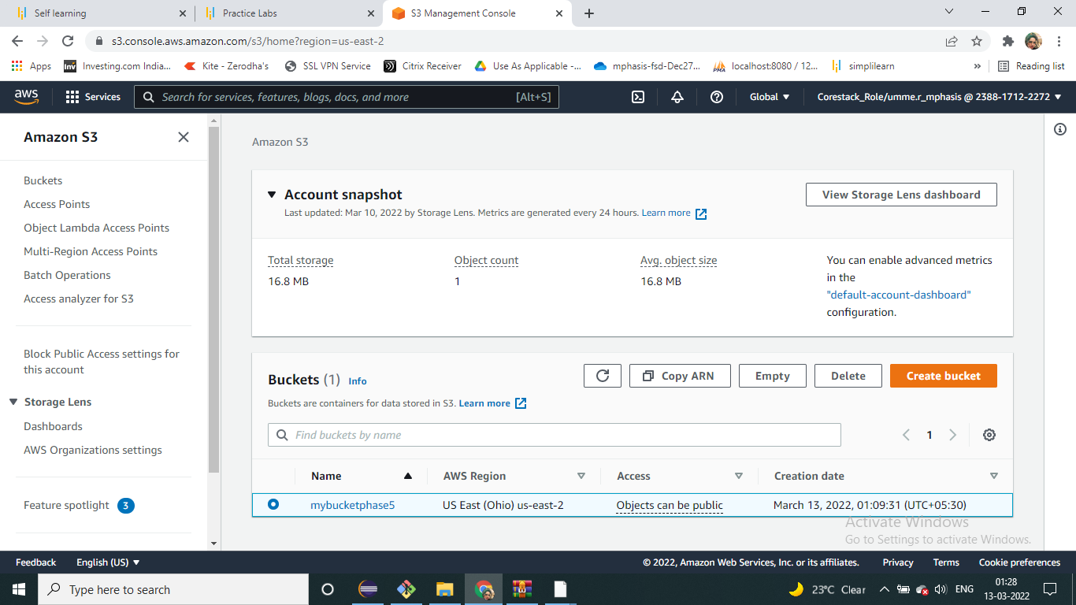

**Deleting the bucket**

